# Project Documentation Phase 4

Event Management & Ticketing System on Salesforce

## Phase 4: Process Automation (Admin)

### 1. Introduction

In this phase, we implement automation features in Salesforce to streamline event operations. The goal is to minimize manual tasks, improve accuracy, and ensure timely notifications for users (Organizers, Attendees, Ticketing Staff, and Admins). Salesforce provides multiple tools for process automation, and we apply them to enforce business rules, trigger actions, and guide the event lifecycle.

### 2. Preparation

Before building automation, we must: - Enable **Email Deliverability** (All Email) in Setup → Deliverability. - Create **Lightning Email Templates** for confirmation, reminders, and feedback. - Configure **Custom Notification Types** for real-time alerts (e.g., Registration Success, Ticket Scanned). - Create **Sample Records** for Events, Tickets, and Attendees to test automation.

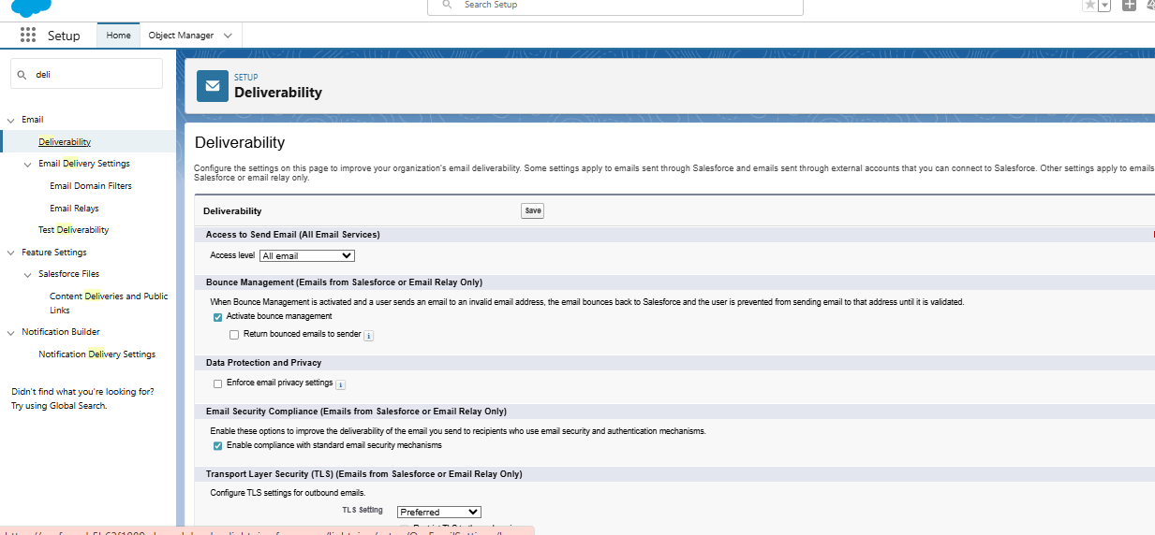

### 3. Automation Components

#### A. Validation Rules

**Purpose:** Ensure data integrity by restricting incorrect or incomplete data entry.

* Example Rules in Project:
  + Prevent Attendee registration without valid Email format.
  + Ensure Event Capacity must be greater than zero.
  + Prevent duplicate Ticket Types per Event.

✅ These rules ensure clean, consistent data before saving records.

#### Flow Builder

**Purpose:** The most powerful Salesforce automation tool.

Types used in project: - **Record-Triggered Flow:** When a Ticket is scanned, update Attendee Check-in Status. - **Screen Flow:** Guided Attendee Registration Wizard. - **Scheduled Flow:** Send reminder emails/SMS 2 days before Event Date. - **Auto-Launched Flow:** Triggered by Process Builder to send post-event survey links.

✅ Flows provide flexible automation for the entire event lifecycle.

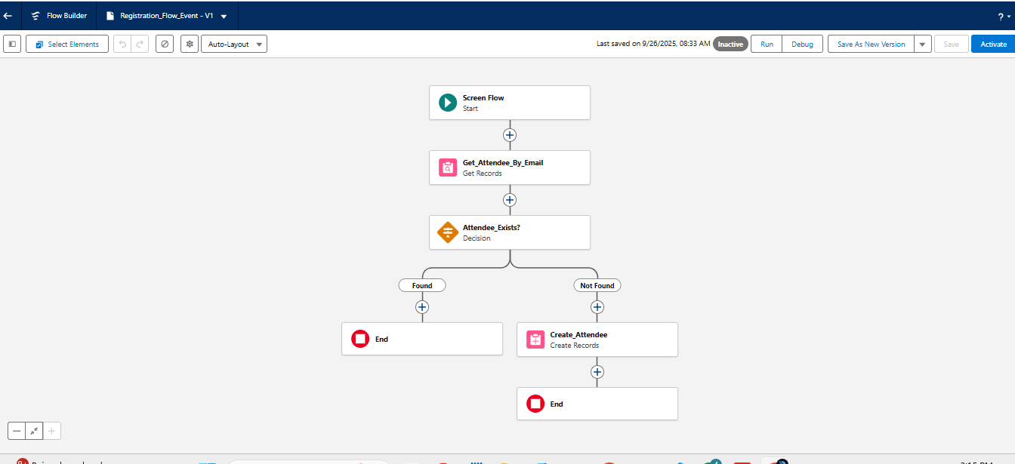

#### 

#### B. Workflow Rules

**Purpose:** Automate simple “if-then” actions based on record changes.

* Example Use Case: When a Ticket is created, send a **confirmation email** to the Attendee.
* Example Use Case: When Event Date is updated, notify all registered Attendees.

✅ Helps automate routine alerts and field updates.

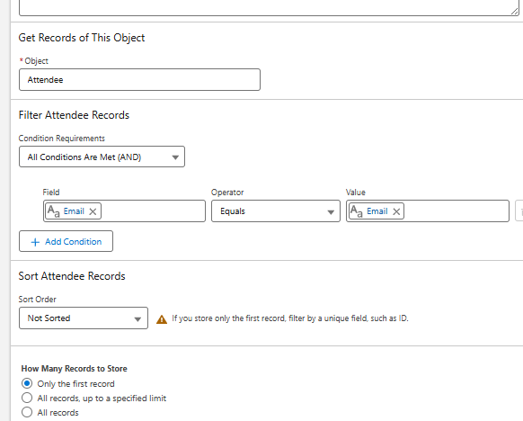

#### C. Process Builder

**Purpose:** Handle more advanced automation with multiple conditions and actions.

* Example Use Case:
  1. When a new Attendee registers → Status = “Pending Confirmation”.
  2. Create a Task for Staff to verify details.
  3. Send a Custom Notification to the Attendee.

✅ Provides multi-step logic in one process.

#### D. Approval Process

**Purpose:** Automate approvals for sensitive processes.

* Example Use Case: An Organizer creates a new Event → requires Admin approval before publishing.
* Approval Path: Admin reviews → Approve (Status = Approved) / Reject (Status = Rejected).
* Notifications sent at each step.

✅ Ensures quality control for event publishing.

#### F. Email Alerts

**Purpose:** Automatically send emails based on triggers.

* Example Use Cases:
  + On Registration → Send Ticket Confirmation email with QR Code.
  + On Event Reminder → Send “Your event is coming soon” email.
  + On Feedback Collection → Send survey link email.

✅ Keeps attendees engaged and informed.

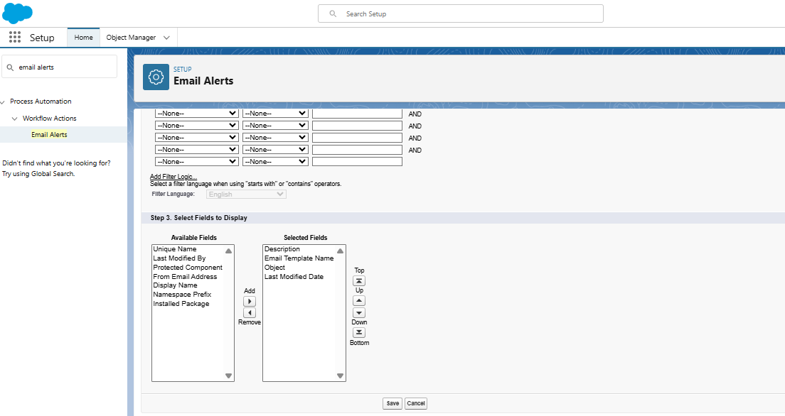

#### G. Field Updates

**Purpose:** Auto-update fields to reduce manual work.

* Example Use Cases:
  + When Ticket is scanned → update Ticket Status = “Checked-In”.
  + When Event Date passes → update Event Status = “Completed”.

✅ Maintains accurate record statuses automatically.

#### H. Tasks

**Purpose:** Create tasks automatically for Organizers or Staff.

* Example Use Cases:
  + When new Event is created → Admin gets task to review setup.
  + When large event reaches 80% capacity → Staff gets task to arrange logistics.

✅ Ensures operational follow-ups are not missed.

#### I. Custom Notifications

**Purpose:** Provide real-time in-app alerts.

* Example Use Cases:
  + Attendee receives notification when Ticket is confirmed.
  + Organizer receives notification when Event capacity is full.
  + Staff receives notification when QR scan check-in fails.

✅ Improves responsiveness and user experience.

### 4. Benefits of Process Automation

* Reduced manual effort for Organizers and Staff.
* Faster response times for Attendees.
* Improved data accuracy through validation rules.
* Enhanced experience with timely emails and notifications.
* Standardized approval flows to maintain event quality.

✅ **Phase 4 Deliverable:** By the end of Phase 4, we have: - Implemented validation rules, workflows, and approval processes. - Configured process builder, flows, email alerts, and field updates. - Automated notifications and task assignments. - Delivered an efficient, responsive event management process.

This forms the foundation for **Phase 5: Apex Programming (Developer).**